***Question Number 1:***

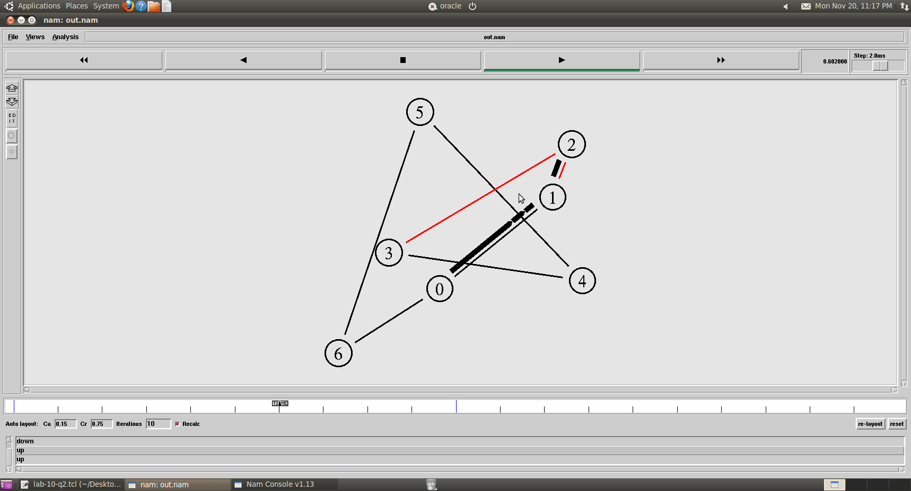

Code:

set simulator [new Simulator]

$simulator set rtproto DV

set namFile [open out.nam w]

$simulator namtrace-all $namFile

proc wrap_up {} {

global simulator namFile

$simulator flush-trace

close $namFile

exec nam out.nam &

exit 0

}

for {set i 0} {$i < 7} {incr i} {

set nodes($i) [$simulator node]

}

for {set i 0} {$i < 7} {incr i} {

$simulator duplex-link $nodes($i) $nodes([expr ($i+1)%7]) 512kb 5ms DropTail

}

set udpAgent [new Agent/UDP]

$simulator attach-agent $nodes(0) $udpAgent

set cbrSource [new Application/Traffic/CBR]

$cbrSource set packetSize_ 1048

$cbrSource set interval_ 0.01

$cbrSource attach-agent $udpAgent

set nullAgent [new Agent/Null]

$simulator attach-agent $nodes(3) $nullAgent

$simulator connect $udpAgent $nullAgent

$simulator at 0.5 "$cbrSource start"

$simulator rtmodel-at 0.4 down $nodes(2) $nodes(3)

$simulator rtmodel-at 1.0 up $nodes(1) $nodes(2)

$simulator at 1.5 "$cbrSource stop"

$simulator at 2.5 "wrap_up"

$simulator run

***Question number 2:***

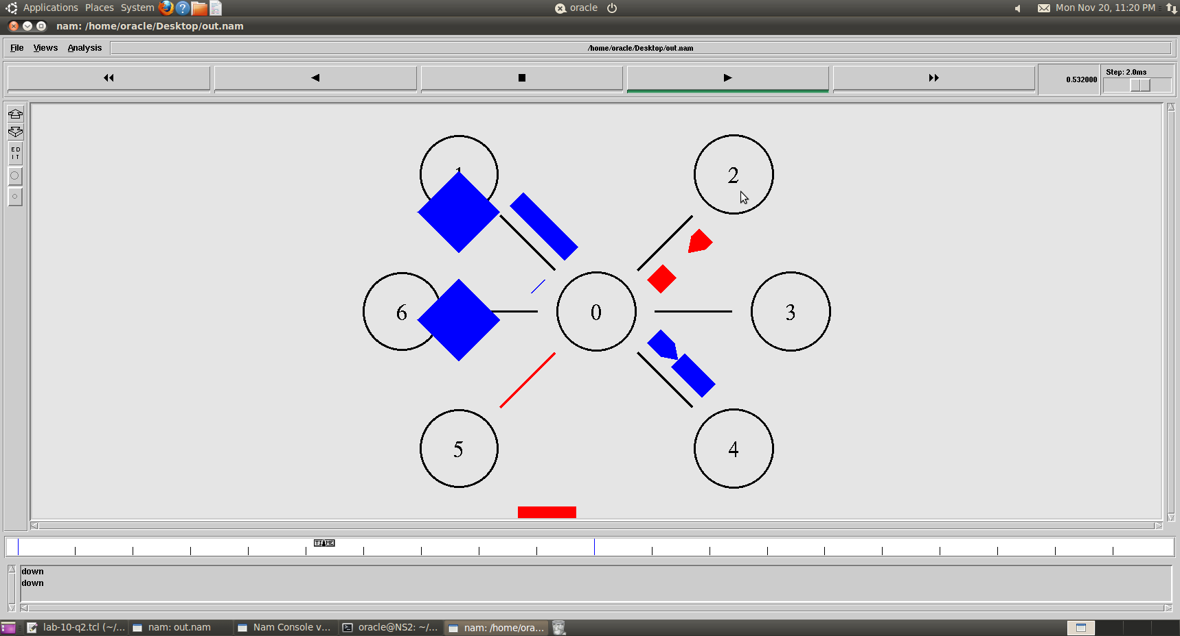

Code:

set ns [new Simulator]

$ns color 1 blue

$ns color 2 red

$ns rtproto DV

set nf [open out.nam w]

$ns namtrace-all $nf

proc finish {} {

global ns nf

$ns flush-trace

close $nf

exec nam out.nam

exit 0

}

for {set i 0} {$i < 7} {incr i} {

set n($i) [$ns node]

}

for {set i 1} {$i < 7} {incr i} {

$ns duplex-link $n(0) $n($i) 512Kb 10ms SFQ

}

$ns duplex-link-op $n(0) $n(1) orient left-up

$ns duplex-link-op $n(0) $n(2) orient right-up

$ns duplex-link-op $n(0) $n(3) orient right

$ns duplex-link-op $n(0) $n(4) orient right-down

$ns duplex-link-op $n(0) $n(5) orient left-down

$ns duplex-link-op $n(0) $n(6) orient left

set tcp0 [new Agent/TCP]

$tcp0 set class_ 1

$ns attach-agent $n(1) $tcp0

set sink0 [new Agent/TCPSink]

$ns attach-agent $n(4) $sink0

$ns connect $tcp0 $sink0

set udp0 [new Agent/UDP]

$udp0 set class_ 2

$ns attach-agent $n(2) $udp0

set null0 [new Agent/Null]

$ns attach-agent $n(5) $null0

$ns connect $udp0 $null0

set cbr0 [new Application/Traffic/CBR]

$cbr0 set rate_ 256Kb

$cbr0 attach-agent $udp0

set ftp0 [new Application/FTP]

$ftp0 attach-agent $tcp0

$ns rtmodel-at 0.5 down $n(0) $n(5)

$ns rtmodel-at 0.9 up $n(0) $n(5)

$ns rtmodel-at 0.7 down $n(0) $n(4)

$ns rtmodel-at 1.2 up $n(0) $n(4)

$ns at 0.1 "$ftp0 start"

$ns at 1.5 "$ftp0 stop"

$ns at 0.2 "$cbr0 start"

$ns at 1.3 "$cbr0 stop"

$ns at 2.0 "finish"

$ns run